EXPERIMENT-2

AIM

To design and develop a responsive banking user interface using only HTML and CSS, which includes a balance display, deposit button, and withdraw button.

OBJECTIVE

* Practice modern layout techniques using HTML and CSS.
* Create a responsive and visually clean UI that works on desktops, tablets, and mobile devices.
* Apply design principles like alignment, spacing, and centering using Flexbox and media queries.

THEORY

HTML and CSS provide powerful tools for building visually appealing and responsive interfaces. In this task:

* HTML structures the content (balance, buttons).
* CSS Flexbox centers content both vertically and horizontally and manages layout.
* Media queries make the layout responsive across different screen sizes.
* The UI must be static—no interactivity with JavaScript.

CODE:

|  |
| --- |
| <!DOCTYPE html>  <html lang="en">  <head>  <meta charset="UTF-8">  <title>Banking UI</title>  <meta name="viewport" content="width=device-width, initial-scale=1.0">  <style> * {  box-sizing: border-box;  } |

|  |
| --- |
| body { font-family: Arial, sans-serif; background-color: #f0f2f5; margin: 0; padding: 0; display: flex; align-items: center; justify-content: center; height: 100vh;  }  .bank-ui { background-color: white; padding: 30px; border-radius: 10px; box-shadow: 0 4px 8px rgba(0,0,0,0.1); text-align: center; width: 300px;  }    .balance { font-size: 24px; font-weight: bold; color: #333; margin-bottom: 20px; padding: 15px; border: 2px solid #4CAF50; border-radius: 5px;  }    .button-group { display: flex; justify-content: space-between; gap: 10px;  }  button { padding: 10px; flex: 1; background-color: #4CAF50; color: white; border: none; border-radius: 5px; cursor: default;  }    @media (max-width: 500px) {  .bank-ui { width: 90%;  }    .button-group { |

flex-direction: column;

}

}

</style>

</head>

<body>

<div class="bank-ui">

<div class="balance">Balance: ₹50,000</div>

<div class="button-group">

<button>Deposit</button>

<button>Withdraw</button>

</div>

</div>

</body>

</html>

OUTPUT

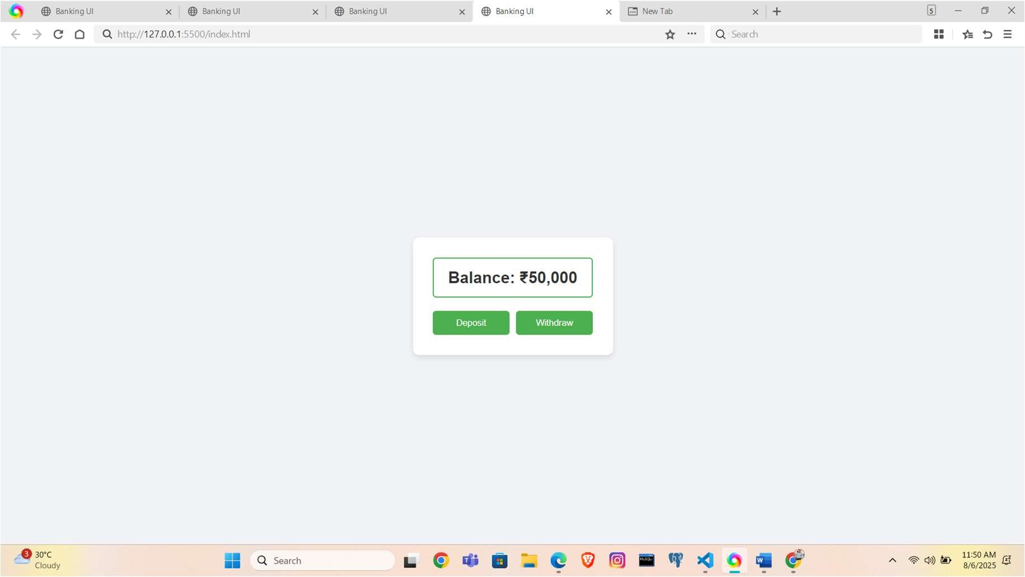

LEARNING OUTCOME

* Use Flexbox for layout and centering.
* Build responsive web interfaces using media queries.
* Style HTML elements professionally using modern CSS practices.
* Create clean, structured UI components without using JavaScript.